**3.3.2 Servo motor**

**It is a motor which can rotate with great precision. If application needs to move some object at some specific angle, then servo motor can be used.**

**We require this kind of rotation for our “Robotic Arm”. We are using servo motor to ope and close the arm grip.**

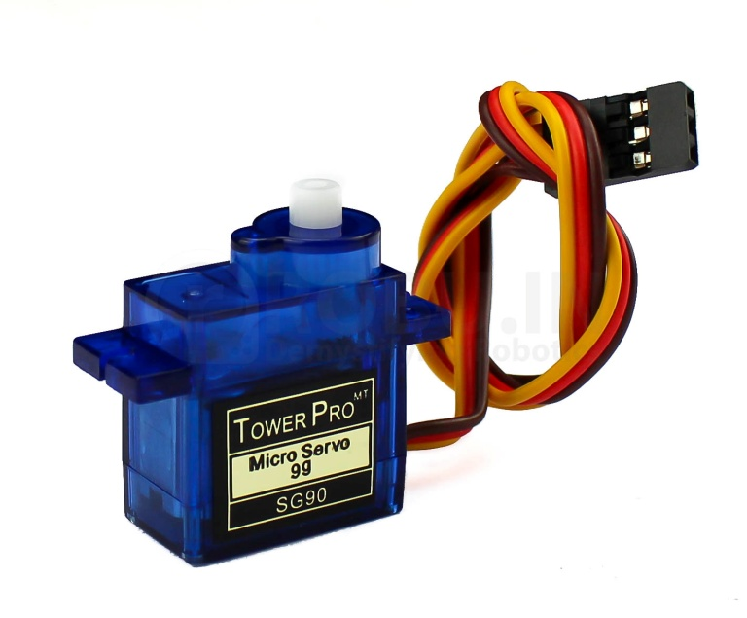

**Specifications**

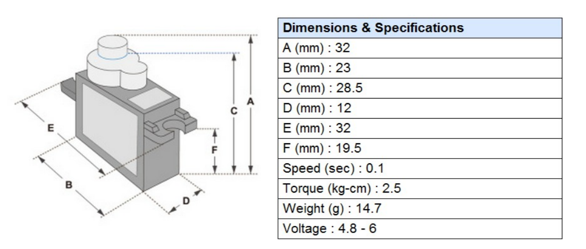

Rotation & signals

|  |  |
| --- | --- |
| Pulse | Rotation angle |
| 1ms | -90 |
| 1.5ms | 0 |
| 2ms | 90 |

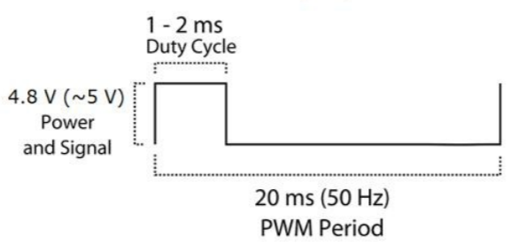

* So we have to maintain duty cycle between 1-2ms in order to rotate the motor in 180 degrees.

But the servo motor is coupled to one of the arm of robotic arm, & to open the arm fully we need only 45 degree rotation .

So

Duty cycle= 1.5+(angle of rotation in degrees /180)

=1.5+(45 /180)

=1.75 ms

* Weight calculation

Torque given is 2.5 kg-cm

Means it can lift upto 2.5 kg with 1 cm of shaft length

Our arm length is 8.5 cm

So

Maximum lifting weight = torque/arm length

=2.5/8.5

=0.2941 kg

=294 gm

* Maximum arm opening is 11.3 cm ,so maximum holding length is 11.3cm .

It is supposed to hold objects upto 2-10 cm more precisely.

* Arm opening time

Speed given is 0.1 sec

Means 10 rps or 600rpm

So for 360 degree rotation, it takes 100 ms

Therefore for 45 degree rotation it will take 100/8=12.5 ms

It means arm will open or close in 12.5 msec (for full speed).

Reference <http://www.ee.ic.ac.uk/pcheung/teaching/DE1_EE/stores/sg90_datasheet.pdf>